# **Module 2 Assignment 2: JavaScript Language**

## IFT 544: Middleware Prog & Database Sec (2023 Fall)

Santrupth Sunkari

Prof. Dinesh Sthapit

September 3, 2023

Installation of GIT:

Creation of package.json:

* Screenshot of hello there:

Code:

// Student Name: Santrupth Sunkari

// Student ID: 1226226978

// Date: 09/02/2023

const message = 'Hello There';

console.log(message);

Output:

Hello There

* Screenshot of studentName and Message:

Code:

// Student Name: Santrupth Sunkari

// Student ID: 1226226978

// Date: 09/02/2023

const message = 'Hello There';

const studentName = 'Santrupth Sunkari'

console.log(message + ' ' +studentName);

Output:

Hello There Santrupth Sunkari

* Screenshot of greetTheStudent:

Code:

// Student Name: Santrupth Sunkari

// Student ID: 1226226978

// Date: 09/02/2023

function greetTheStudent(studentName){//parameter

const message = 'Hello There';

const greeting = message + ' ' + studentName

return greeting;

}

const student = 'Santrupth Sunkari';

const greet = greetTheStudent(student); //argument

console.log(greet);

//console.log(message + ' ' +studentName);

//console.log(message + ' ' +studentName2);

Output:

Hello There Santrupth Sunkari

* Refactored Code:

Code:

// Student Name: Santrupth Sunkari

// Student ID: 1226226978

// Date: 09/02/2023

function greetTheStudent(studentName){ //parameter

const greeting = `Hello there ${studentName}`;

return greeting;

}

const student = 'Mary Jane';

const greet = greetTheStudent(student); //argument

console.log(greet);

// console.log(message + ' ' + studentName);

// console.log(message + ' ' + studentName2);

Output:

Hello there Mary Jane

* DRY Concept:

Code:

// Student Name: Santrupth Sunkari

// Student ID: 1226226978

// Date: 09/02/2023

function greetTheStudent(studentName){ //parameter

    return `Hello there ${studentName}`;

}

//Do not Repeat Yourself (DRY)

const student = 'Mary Jane';

const greet = greetTheStudent(student); //argument

console.log(greet);

// console.log(message + ' ' + studentName);

// console.log(message + ' ' + studentName2);

Output:

Hello there Mary Jane

Anonymous Function:

Code:

// Student Name: Santrupth Sunkari

// Student ID: 1226226978

// Date: 09/02/2023

// function greetTheStudent(studentName){ //parameter  // Name Function

//     return `Hello there ${studentName}`;

// }

//Fat Arrow Function

const greetTheStudent = function (studentName){ //parameter // Anonymous Function   // Expression

    return `Hello there ${studentName}`;

}

const student = 'Mary Jane';

const greet = greetTheStudent(student); //argument

console.log(greet);

// console.log(message + ' ' + studentName);

// console.log(message + ' ' + studentName2);

Output:

Hello there Mary Jane

* Fat Arrow Function:

Code:

// Student Name: Santrupth Sunkari

// Student ID: 1226226978

// Date: 09/02/2023

// function greetTheStudent(studentName){ //parameter  // Name Function

//     return `Hello there ${studentName}`;

// }

//Fat Arrow Function

// const greetTheStudent = function (studentName){ //parameter // Anonymous Function   // Expression

//     return `Hello there ${studentName}`;

// }

//Fat Arrow Function

const greetTheStudent = (studentName) => { //parameter // Anonymous Function   // Expression

    return `Hello there ${studentName}`;

}

const student = 'Mary Jane';

const greet = greetTheStudent(student); //argument

console.log(greet);

// console.log(message + ' ' + studentName);

// console.log(message + ' ' + studentName2);

Output:

Hello there Mary Jane

* One Liner Function:

Code:

// Student Name: Santrupth Sunkari

// Student ID: 1226226978

// Date: 09/02/2023

// function greetTheStudent(studentName){ //parameter  // Name Function

//     return `Hello there ${studentName}`;

// }

//Fat Arrow Function

// const greetTheStudent = function (studentName){ //parameter // Anonymous Function   // Expression

//     return `Hello there ${studentName}`;

// }

//Fat Arrow Function

const greetTheStudent = (studentName) => { //parameter // Anonymous Function   // Expression

    return `Hello there ${studentName}`;

}

const student = 'Mary Jane';

const greet = greetTheStudent(student); //argument

console.log(greet);

// console.log(message + ' ' + studentName);

// console.log(message + ' ' + studentName2);

Output:

Hello there Mary Jane

* One Liner Code:

Code:

// Student Name: Santrupth Sunkari

// Student ID: 1226226978

// Date: 09/02/2023

// function greetTheStudent(studentName){ //parameter  // Name Function

//     return `Hello there ${studentName}`;

// }

//Fat Arrow Function

// const greetTheStudent = function (studentName){ //parameter // Anonymous Function   // Expression

//     return `Hello there ${studentName}`;

// }

//Fat Arrow Function

const greetTheStudent = studentName => `Hello there ${studentName}`;

const student = 'Mary Jane';

const greet = greetTheStudent(student); //argument

console.log(greet);

// console.log(message + ' ' + studentName);

// console.log(message + ' ' + studentName2);

Ouput:

Hello there Mary Jane

* Positional Argument:

Code:

// Student Name: Santrupth Sunkari

// Student ID: 1226226978

// Date: 09/02/2023

// function greetTheStudent(studentName){ //parameter  // Name Function

//     return `Hello there ${studentName}`;

// }

//Fat Arrow Function

// const greetTheStudent = (studentName) => { //parameter // Anonymous Function   // Expression

//     return `Hello there ${studentName}`;

// }

const greetTheStudent = studentName => `Hello there ${studentName}`;

const fullName = function(firstName, middleName, lastName){

    return `${lastName}, ${middleName}, ${firstName}`

}

// const student = 'Mary Jane';

// const greet = greetTheStudent(student); //argument

// console.log(greet);

const titleName = fullName('Mary','R','Jane')

console.log(titleName)

// console.log(message + ' ' + studentName);

// console.log(message + ' ' + studentName2);

Output:

Jane, R, Mary

* Arrow Function for positional argument:

Code:

// Student Name: Santrupth Sunkari

// Student ID: 1226226978

// Date: 09/02/2023

// function greetTheStudent(studentName){ //parameter  // Name Function

//     return `Hello there ${studentName}`;

// }

//Fat Arrow Function

// const greetTheStudent = (studentName) => { //parameter // Anonymous Function   // Expression

//     return `Hello there ${studentName}`;

// }

const greetTheStudent = studentName => `Hello there ${studentName}`;

const fullName = (firstName, middleName, lastName)=>{

    return `${lastName}, ${middleName}, ${firstName}`

}

// const student = 'Mary Jane';

// const greet = greetTheStudent(student); //argument

// console.log(greet);

const titleName = fullName('Mary','R','Jane')

console.log(titleName)

// console.log(message + ' ' + studentName);

// console.log(message + ' ' + studentName2);

Output:

Jane, R, Mary

* Fat Arrow Function for Positional Argument:

Code:

// Student Name: Santrupth Sunkari

// Student ID: 1226226978

// Date: 09/02/2023

// function greetTheStudent(studentName){ //parameter  // Name Function

//     return `Hello there ${studentName}`;

// }

//Fat Arrow Function

// const greetTheStudent = (studentName) => { //parameter // Anonymous Function   // Expression

//     return `Hello there ${studentName}`;

// }

const greetTheStudent = studentName => `Hello there ${studentName}`;

const fullName = (firstName, middleName, lastName)=>`${lastName}, ${middleName}, ${firstName}`

// const student = 'Mary Jane';

// const greet = greetTheStudent(student); //argument

// console.log(greet);

const titleName = fullName('Mary','R','Jane')

console.log(titleName)

// console.log(message + ' ' + studentName);

// console.log(message + ' ' + studentName2);

Output:

Jane, R, Mary

* Datatype:

Code:

// Student Name: Santrupth Sunkari

// Student ID: 1226226978

// Date: 09/02/2023

var age = 10;   // Int

var salary = 15.00; //Double

console.log(`The variable type of age is ${typeof(age)}`);

Output:

The variable type of age is number

* Screenshot of Datatype for both variables:

Code:

// Student Name: Santrupth Sunkari

// Student ID: 1226226978

// Date: 09/02/2023

var age = 10;   // Int

var salary = 15.00; //Double

console.log(`The variable type of age is ${typeof(age)}`);

console.log(`The variable type of salary is ${typeof(salary)}`);

Output:

The variable type of age is number

The variable type of salary is number

* Datatype Name:

Code:

// Student Name: Santrupth Sunkari

// Student ID: 1226226978

// Date: 09/02/2023

var age = 10;   // Int

var salary = 15.00; //Double

console.log(`The variable type of age is ${typeof(age)}`);

console.log(`The variable type of salary is ${typeof(salary)}`);

var name = 'John Smith';

console.log(`The variable type of name is ${typeof(name)}`);

Ouput:

The variable type of age is number

The variable type of salary is number

The variable type of name is string

* Variable as function:

Code:

// Student Name: Santrupth Sunkari

// Student ID: 1226226978

// Date: 09/02/2023

var age = 10;   // Int

var salary = 15.00; //Double

console.log(`The variable type of age is ${typeof(age)}`);

console.log(`The variable type of salary is ${typeof(salary)}`);

var name = 'John Smith';

console.log(`The variable type of name is ${typeof(name)}`);

const displayGreetings = function(name, year){ //parameter  // Name Function

    console.log(`Happy new year ${year} ${name}`)

}

console.log(`The variable type of displayGreetings is ${typeof(displayGreetings)}`);

Output:

The variable type of age is number

The variable type of salary is number

The variable type of name is string

The variable type of displayGreetings is function

* Displaying Greeting message:

Code:

// Student Name: Santrupth Sunkari

// Student ID: 1226226978

// Date: 09/02/2023

var age = 10;   // Int

var salary = 15.00; //Double

// console.log(`The variable type of age is ${typeof(age)}`);

// console.log(`The variable type of salary is ${typeof(salary)}`);

// var name = 'Joh Smith';

// console.log(`The variable type of name is ${typeof(name)}`);

const displayGreetings = function(name, year){ //parameter  // Name Function

    console.log(`Happy new year ${year} ${name}`)

}

console.log(`The variable type of displayGreetings is ${typeof(displayGreetings)}`);

const displayGreetingsWithEMoji = function(name, year){ //parameter  // Name Function

    console.log(`😊 😊 Happy new year ${year} ${name} 😊 😊`)

}

var greet= {};

if(age > 10){

    greet = displayGreetings;

}

else{

    greet = displayGreetingsWithEMoji;

}

greet('Sam',2022)

Output:

The variable type of displayGreetings is function

😊 😊 Happy new year 2022 Sam 😊 😊

* Function Calling variable function:

Code:

// Student Name: Santrupth Sunkari

// Student ID: 1226226978

// Date: 09/02/2023

var age = 10;   // Int

var salary = 15.00; //Double

// console.log(`The variable type of age is ${typeof(age)}`);

// console.log(`The variable type of salary is ${typeof(salary)}`);

// var name = 'Joh Smith';

// console.log(`The variable type of name is ${typeof(name)}`);

const displayGreetings = function(name, year){ //parameter  // Name Function

    console.log(`Happy new year ${year} ${name}`)

}

// console.log(`The variable type of displayGreetings is ${typeof(displayGreetings)}`);

const displayGreetingsWithEMoji = function(name, year){ //parameter  // Name Function

    console.log(`😊 😊 Happy new year ${year} ${name} 😊 😊`)

}

const greet = function(name, year, func){

    func(name, year);

}

greet('Sam', 2022, displayGreetingsWithEMoji);

Output:

😊 😊 Happy new year 2022 Sam 😊 😊

* Displaying displayGreetings:

Code:

// Student Name: Santrupth Sunkari

// Student ID: 1226226978

// Date: 09/02/2023

var age = 10;   // Int

var salary = 15.00; //Double

// console.log(`The variable type of age is ${typeof(age)}`);

// console.log(`The variable type of salary is ${typeof(salary)}`);

// var name = 'Joh Smith';

// console.log(`The variable type of name is ${typeof(name)}`);

const displayGreetings = function(name, year){ //parameter  // Name Function

    console.log(`Happy new year ${year} ${name}`)

}

// console.log(`The variable type of displayGreetings is ${typeof(displayGreetings)}`);

const displayGreetingsWithEMoji = function(name, year){ //parameter  // Name Function

    console.log(`😊 😊 Happy new year ${year} ${name} 😊 😊`)

}

const greet = function(name, year, func){

    func(name, year);

}

greet('Sam', 2022, displayGreetingsWithEMoji);

greet('Jane', 2022, displayGreetings)

Output:

😊 😊 Happy new year 2022 Sam 😊 😊

Happy new year 2022 Jane

* Screenshot of array first elements:

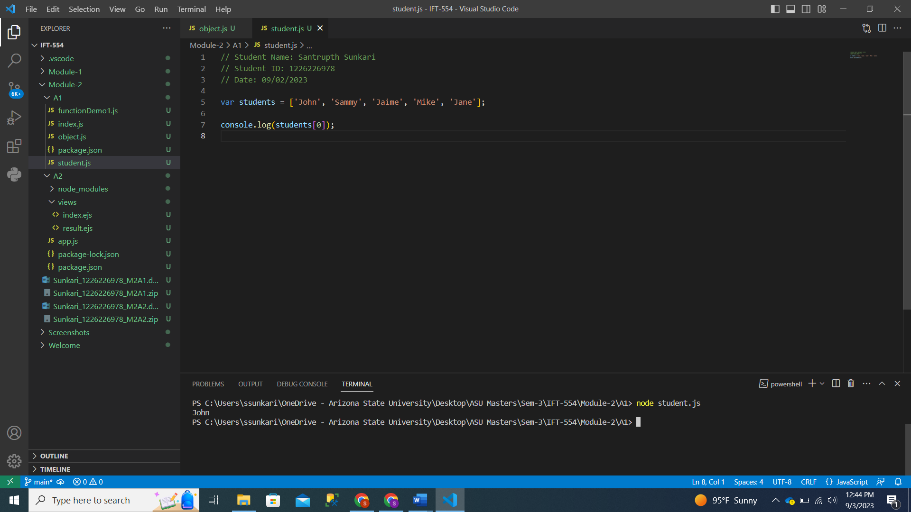

Code:

// Student Name: Santrupth Sunkari

// Student ID: 1226226978

// Date: 09/02/2023

var students = ['John', 'Sammy', 'Jaime', 'Mike', 'Jane'];

console.log(students[0]);

Output:

John

* Screenshot of length of array:

Code:

// Student Name: Santrupth Sunkari

// Student ID: 1226226978

// Date: 09/02/2023

var students = ['John', 'Sammy', 'Jaime', 'Mike', 'Jane'];

console.log(students.length);

Ouput:

5

* Screenshot of Array of Grades:

Code:

// Student Name: Santrupth Sunkari

// Student ID: 1226226978

// Date: 09/02/2023

var students = ['John', 'Sammy', 'Jaime', 'Mike', 'Jane'];

console.log(students[0]);

console.log(students[2]);

console.log(students.length);

var grades = [90,99,89,100,80];

console.log(grades[0]);

console.log(grades[2]);

console.log(grades.length);

Output:

John

Jaime

5

90

89

5

* Screenshot of last and second last element of Array:

Code:

// Student Name: Santrupth Sunkari

// Student ID: 1226226978

// Date: 09/02/2023

var students = ['John', 'Sammy', 'Jaime', 'Mike', 'Jane'];

// console.log(students[0]);

// console.log(students[2]);

// console.log(students.length);

var grades = [90,99,89,100,80];

console.log(grades.length);

console.log(grades[grades.length - 1]);

console.log(grades[grades.length - 2]);

Output:

5

80

100

* Screenshot of Name of Student in Object:

Code:

// Student Name: Santrupth Sunkari

// Student ID: 1226226978

// Date: 09/02/2023

var student = {

    name: 'John Smith',

    birthyear: 2002,

    course: 'IFT 458',

    grade: 90

}

console.log(student['name']);

Output:

John Smith

* Ancient way of printing name of student in object:

Code:

// Student Name: Santrupth Sunkari

// Student ID: 1226226978

// Date: 09/02/2023

var student = {

    name: 'John Smith',

    birthyear: 2002,

    course: 'IFT 458',

    grade: 90

}

console.log(student['name']);

console.log(student.name);

Output:

John Smith

John Smith

* Depiction of Student2 age function displaying age:

Code:

// Student Name: Santrupth Sunkari

// Student ID: 1226226978

// Date: 09/02/2023

var student = {

    name: 'John Smith',

    birthyear: 2002,

    course: 'IFT 458',

    grade: 90,

    age: function(){

        return 2022-this.birthyear;

    }

}

var student2 = {

    name: 'Andy Moore',

    birthyear: 2000,

    course: 'IFT 458',

    grade: 100,

    age: function(){

        return 2022-this.birthyear;

    }

}

// console.log(student['name']);

// console.log(student.name);

console.log(student2.age());

Output:

22

* Depiction of Age of 2 students:

Code:

// Student Name: Santrupth Sunkari

// Student ID: 1226226978

// Date: 09/02/2023

var student = {

    name: 'John Smith',

    birthyear: 2002,

    course: 'IFT 458',

    grade: 90,

    age: function(){

        return 2022-this.birthyear;

    }

}

var student2 = {

    name: 'Andy Moore',

    birthyear: 2000,

    course: 'IFT 458',

    grade: 100,

    age: function(){

        return 2022-this.birthyear;

    }

}

// console.log(student['name']);

// console.log(student.name);

console.log(student2.age());

console.log(student.age());

Output:

22

20

Depiction of Active and Inactive logic for calculation of age:

Code:

// Student Name: Santrupth Sunkari

// Student ID: 1226226978

// Date: 09/02/2023

var student = {

    name: 'John Smith',

    birthyear: 2002,

    course: 'IFT 458',

    grade: 90,

    active: true,

    age: function calculate(){

        if(this.active){

            return 2022-this.birthyear;

        }

        else{

            return 0;

        }

    }

}

var student2 = {

    name: 'Andy Moore',

    birthyear: 2000,

    course: 'IFT 458',

    grade: 100,

    active: false,

    age: function(){

        if(this.active){

            return 2022-this.birthyear;

        }

        else{

            return 0;

        }

    }

}

// console.log(student['name']);

// console.log(student.name);

console.log(student2.age());

console.log(student.age());

Output:

0

20

* Students objects passed in array:

Code:

// Student Name: Santrupth Sunkari

// Student ID: 1226226978

// Date: 09/02/2023

var students= [];

var student = {

    name: 'John Smith',

    birthyear: 2002,

    course: 'IFT 458',

    grade: 90,

    active: true,

    age: function calculate(){

        if(this.active){

            return 2022-this.birthyear;

        }

        else{

            return 0;

        }

    }

}

var student2 = {

    name: 'Andy Moore',

    birthyear: 2000,

    course: 'IFT 458',

    grade: 100,

    active: false,

    age: function(){

        if(this.active){

            return 2022-this.birthyear;

        }

        else{

            return 0;

        }

    }

}

students.push(student);

students.push(student2);

// console.log(student['name']);

// console.log(student.name);

console.log(student2.age());

console.log(student.age());

console.log(students)

Output:

0

20

[

{

name: 'John Smith',

birthyear: 2002,

course: 'IFT 458',

grade: 90,

active: true,

age: [Function: calculate]

},

{

name: 'Andy Moore',

birthyear: 2000,

course: 'IFT 458',

grade: 100,

active: false,

age: [Function: age]

}

]

* Depiction of using forEach for students array:

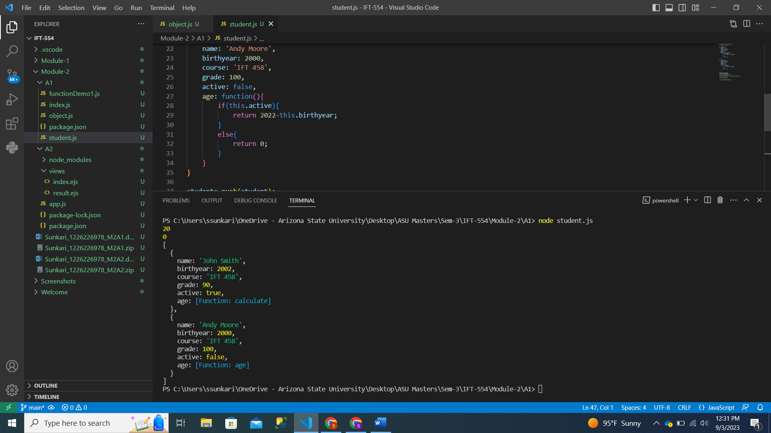

Code:

// Student Name: Santrupth Sunkari

// Student ID: 1226226978

// Date: 09/02/2023

var students= [];

var student = {

    name: 'John Smith',

    birthyear: 2002,

    course: 'IFT 458',

    grade: 90,

    active: true,

    age: function calculate(){

        if(this.active){

            return 2022-this.birthyear;

        }

        else{

            return 0;

        }

    }

}

var student2 = {

    name: 'Andy Moore',

    birthyear: 2000,

    course: 'IFT 458',

    grade: 100,

    active: false,

    age: function(){

        if(this.active){

            return 2022-this.birthyear;

        }

        else{

            return 0;

        }

    }

}

students.push(student);

students.push(student2);

// console.log(student['name']);

// console.log(student.name);

students.forEach((item) => console.log(item.age()));

console.log(students);

// console.log(student2.age());

// console.log(student.age());

Output:

20

0

[

{

name: 'John Smith',

birthyear: 2002,

course: 'IFT 458',

grade: 90,

active: true,

age: [Function: calculate]

},

{

name: 'Andy Moore',

birthyear: 2000,

course: 'IFT 458',

grade: 100,

active: false,

age: [Function: age]

}

]